Study visit- Tong Len NGO, Dharamshala
A full day programme of study visit at Tong Len was organized to understand and observe functioning of Tong Len with planned field based activities like extension of teaching in practical setting of NGO.
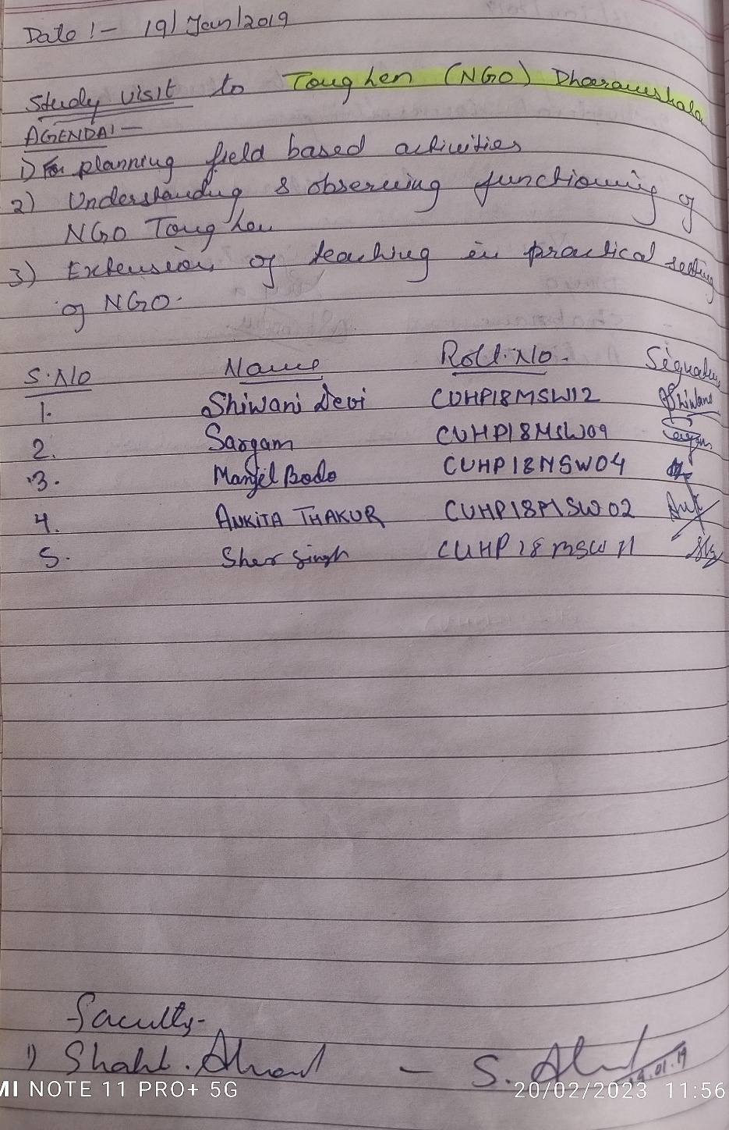
Drug De-addiction Counselling
Five days certificate course (residential) on Drug De-addiction counselling was organized from 05th August to 09th August 2019 by Gunjan Organization for Community Developmnent (RRTC North II) in partnership with NISD, Ministry of Social Justice & Empowerment, Govt. of India at Gunjan Organization Dharamshala, Himachal Pradesh.
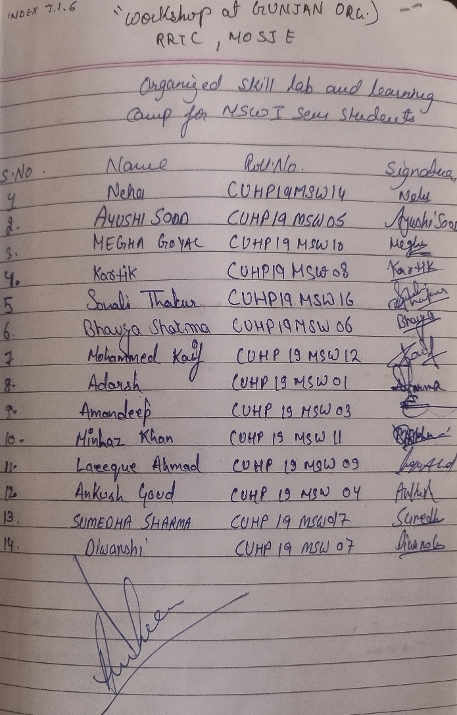
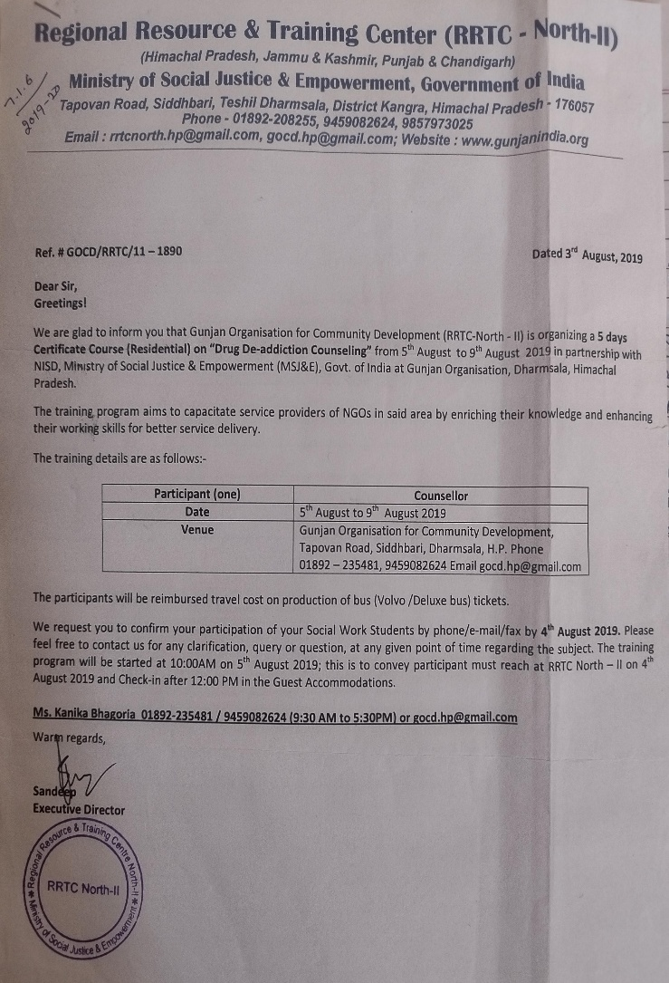
The training programme aims to capacitate service providers of NGOs in said areas by enriching their knowledge and enhancing their working skills for better delivery.

Study visit on World Senior Citizen Day- HelpAge India
A day-long celebration on World Senior Citizens day by HelpAge India in collaboration with SHRAM Ngo was celebrated on 21st August 2019 to discuss about the present conditions of our elders and value them in our lives for the cause and care of poor, isolated, neglected and disadvantaged elderly in India. Faculty and students of Social Work attended the programme.

Swachhta Pakhwada 2019
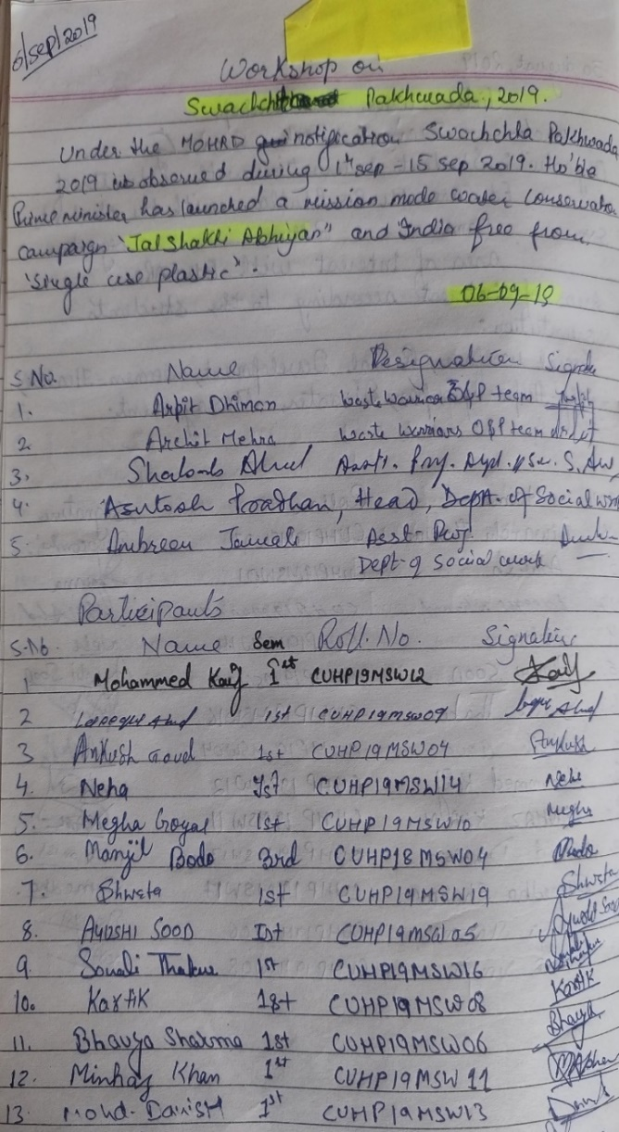
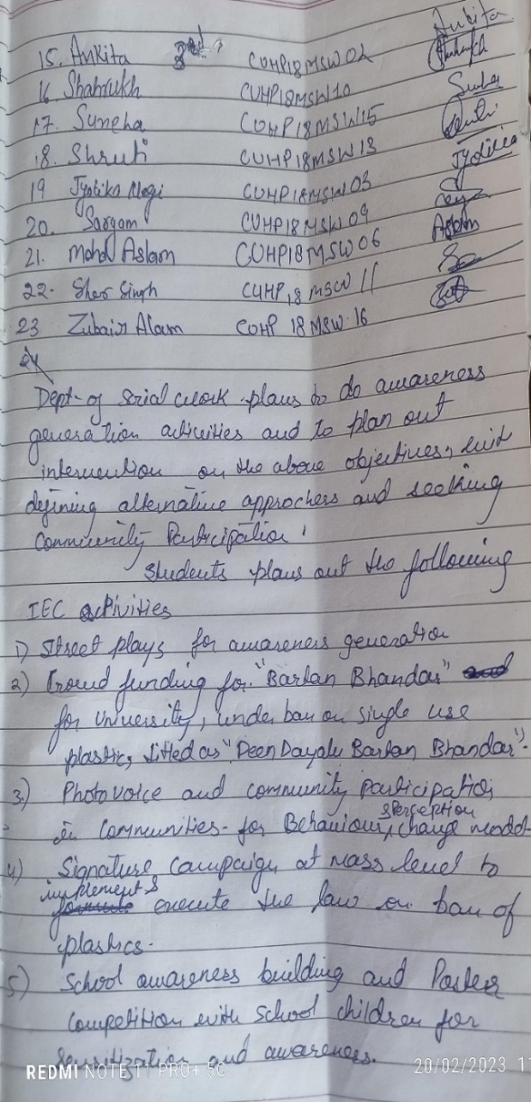
Under the Ministry of Human Resource Development notification, Swachhta Pakhwada was observed from 14th to 15th September 2019 to do awareness generation activities and to plan out intervention along with defining alternative approaches and seeking community participation. Hon’ble Prime Minister had launched a mission mode water conservation campaign, ‘Jal Shakti Abhiyan’ and India free from ‘single use plastic.

