World Health Organization's Intensified Pulse Polio Immunization Programme Training at CUHP, Dharamshala

Objective:
- To train the students to work as an External Monitor in the intensified Pulse Polio Immunization Programme.
- To make student trainees aware of polio vials and their proper use.
- To give proper information to the student trainees about the necessary methodology, precaution and care to be taken in the proper storage and use of polio vials so that they can check whether it is being executed properly by health functionaries of the State.
- To inform them about hygiene and proper sanitization before and after polio vaccination
- To train students in the proper monitoring of polio booths and assessing the functioning of ASHA workers, other health workers, their activities, and display of communication material like banners and posters.
- To train students in house-to-house monitoring and to check whether the immunization program has been properly executed in the high-risk areas and transit zones.

CONTEXT:
There were several challenges in implementing the program which were needed to address before. It was very important to make the students aware of the IPPI program so that they can check the progress on a real-time basis.
Informing and explaining everything related to polio vial and how to use them and make them aware of the booth activities. Planning bit-by-bit was a very challenging task, especially in the case of supplementary immunization activities in HRA’s (High Risk Areas) and transit points which was also very important so that they can be in a position to check the mobile team and check house-to-house to ensure that no one was left-out without being vaccinated. Tackling the doubts of the students and explaining them so that they can develop proper understanding and objective of the program was a challenging part of the whole training program.

The Practice:
Intensified Pulse Polio Immunization (IPPI) Programme has been launched all over India. The pulse Polio was started with the Global Initiative for Eradication of Polio In 1998 following the World Health Assembly Resolution In 1998. It was Launch in India In 1995. India has been declared a polio free country by WHO on 27 march 2014.
Every year vaccination is provided to children under the age of five years to fight polio in the Intensive Pulse Polio Immunization Program, different health Professionals take part to take the drive successful, and with the idea, not a single child should be left behind to make it popular the government makes slogans to increase its reach.
For example: EK BHI BACHA CHOOTA, SURAKSHA CHAKRA TOOTA

An intensive three days exercise is part of this program:
- Activities includes, booth activity takes place where polio drops are provided on the booths.
- Also, house-to-house exercise takes place where WHO’s External Monitors go from house-to-house to check whether all the below 5 years children have taken polio drops or not and if someone has not been provided then they mark it and forward data for their polio immunization and the health workers go to that place and provide them polio drop.
- Finally, high-risk area activity has to be done where the monitors go to the slums to identify and reassure all those who have been left out the importance of immunization & polio drop administration to children. A mobile team is made available for their immunization.

TOOLS:
In this entire exercise, different areas are assigned to the students of social work from WHO to act as External Monitors who have to accomplish a very important job by checking the success of the IPPI Programme.
The students are provided a micro-plan and the address of the booths which they have to visit and check everything physically.
- On the first day, the External Monitors go to their assigned booth and checked every parameter.
- On the second day, a designated area that was chosen earlier was assigned to the External Monitors along with a micro-plan. The External Monitors then visit each household in the area and check the progress of immunization.
- On the third day, visit to identified High-Risk area take place & the progress in that area is checked. All the activities and records maintained are checked and physically verified; the same is noted down by the External Monitor and based on that record and the activity done by the External Monitor it shall be proven that the exercise was successful.

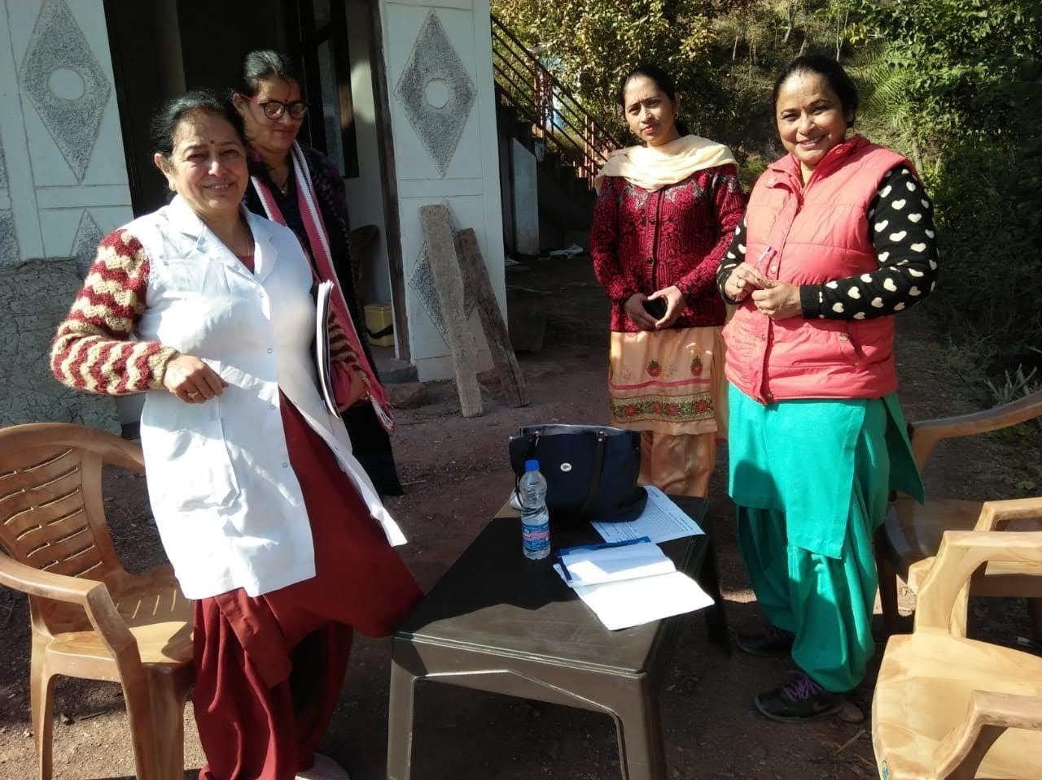
Pulse Polio Immunization Programme

Record of National Immunization Day (NID) April 2017
Deployment of MSW students of the Department of Social Work, CUHP in various districts/pockets of Himachal Pradesh as External Monitors
S.No | Name of Monitor | District Allotted | Deployment in District | Block Monitored
1 | Kuldeep | Kangra | Hamirpur | Toni Devi &Sujanpur
2 | Rakesh Kumar | Kangra | Shimla | Mashobra
3 | Md. Attaullah | Kangra | Shimla | Shimla Urban
4 | Vikas Sharma | Kangra | Sirmour | Paonta Sahib
5 | Rajesh Kumar | Kangra | Sirmour | Dhagehra
6 | Rahul Kumar | Kangra | Solan | Baddi-1
7 | DikshaParmar | Kangra | Solan | Baddi-2
8 | ShubhamGarg | Kangra | Solan | Solan/Kandaghat
9 | Bineet Kumar | Kangra | Solan | Barotiwala
10 | Anil Kumar | Kangra | Solan | Dharampur
11 | Md. Rehan Khan | Kangra | Una | Gagret
12 | Md. Masadul Islam | Kangra | Una | Amb
Digital India Campaign
As a part of PM’s Vision of Corruption free India by making India a LESS CASH economy. A day-long workshop was organized to streamline the VISAKA Project Manjhgram Block of Shapur on Friday 3th Feb, 2017 from 02.00 PM to 04.00 PM.
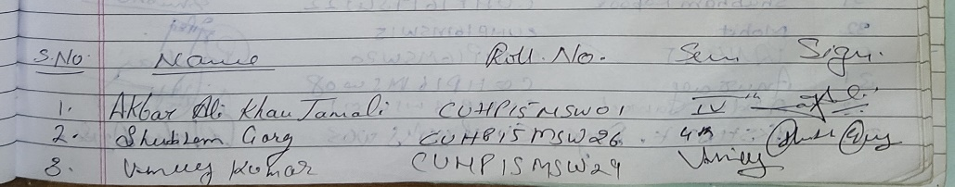
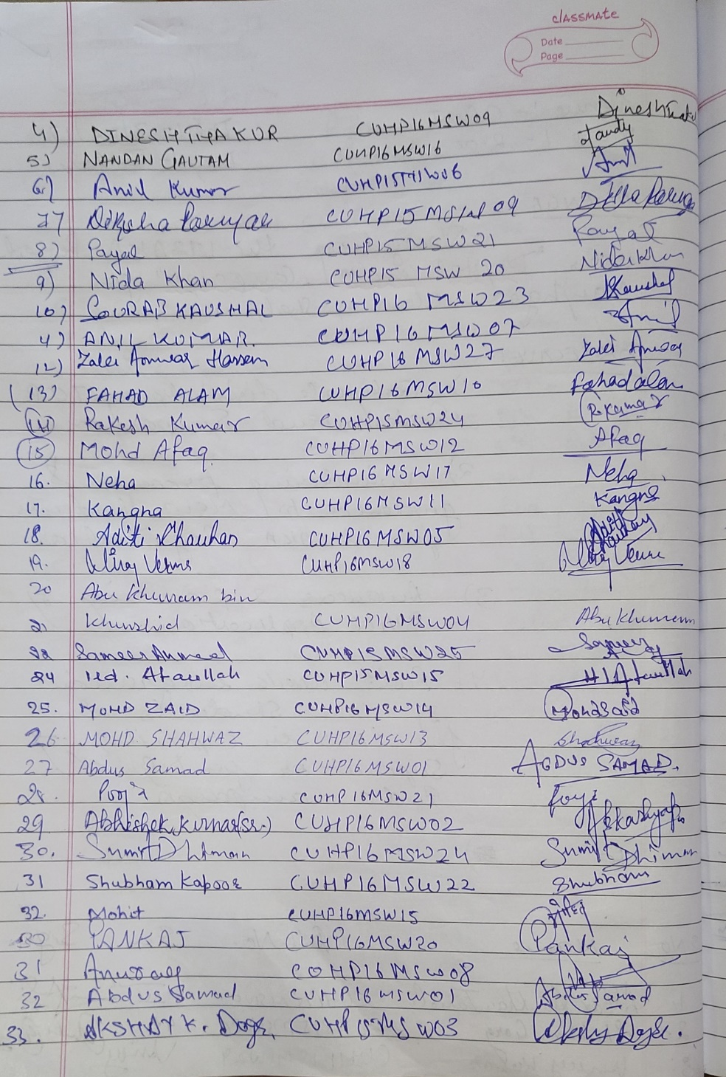

Domestic Violence
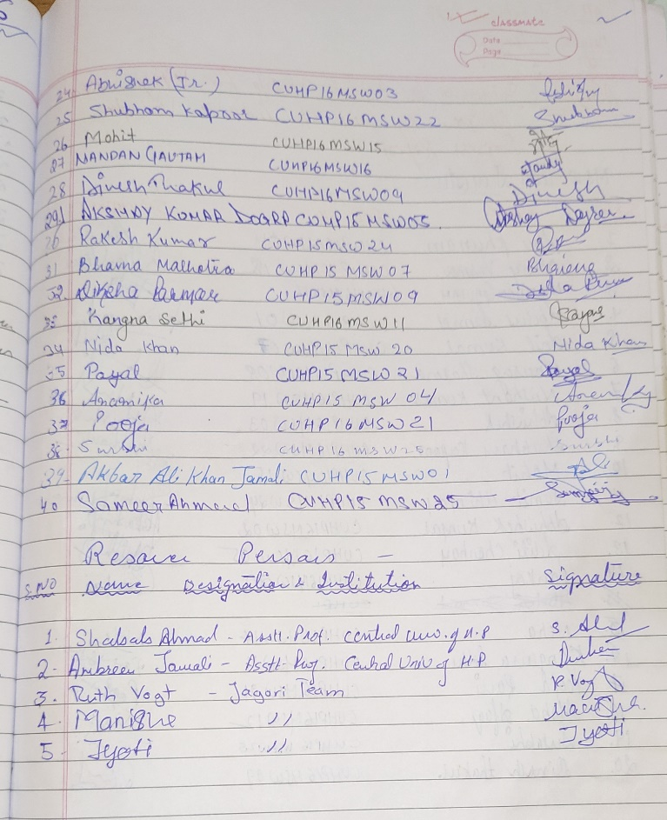
Workshop on “Domestic Violence with collaboration with Frankfurt University & Jagori NGO on Monday 6th Feb 2017 at 2:45 PM.
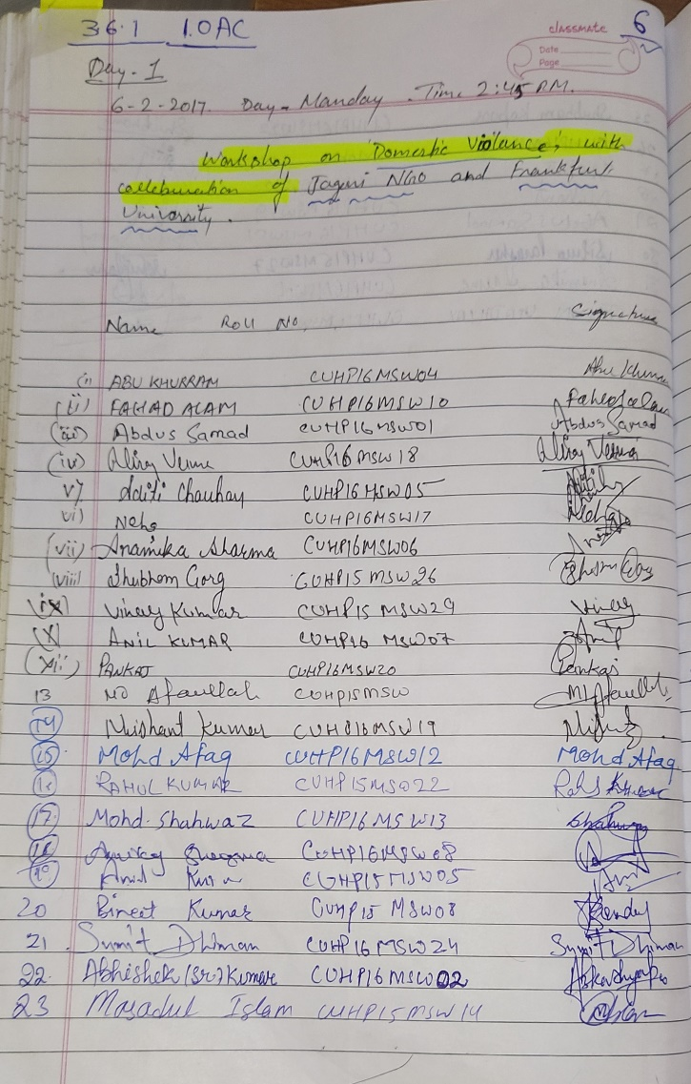

Vitiya Saksharta Abhiyan
On the Call of MHRD, CUHP is actively participating in the mission of Financial Literacy. Under Unnat Bharat Abhiyaan, Department of Social Work done IPC & IEC activities with the following community members of the Panchayat and Shop Owners of the Communities. Also, submitted Intensive Schedule for Vittiya Saksharta Abhiyan to Gove. of India on Tuesday 7th Feb 2017.

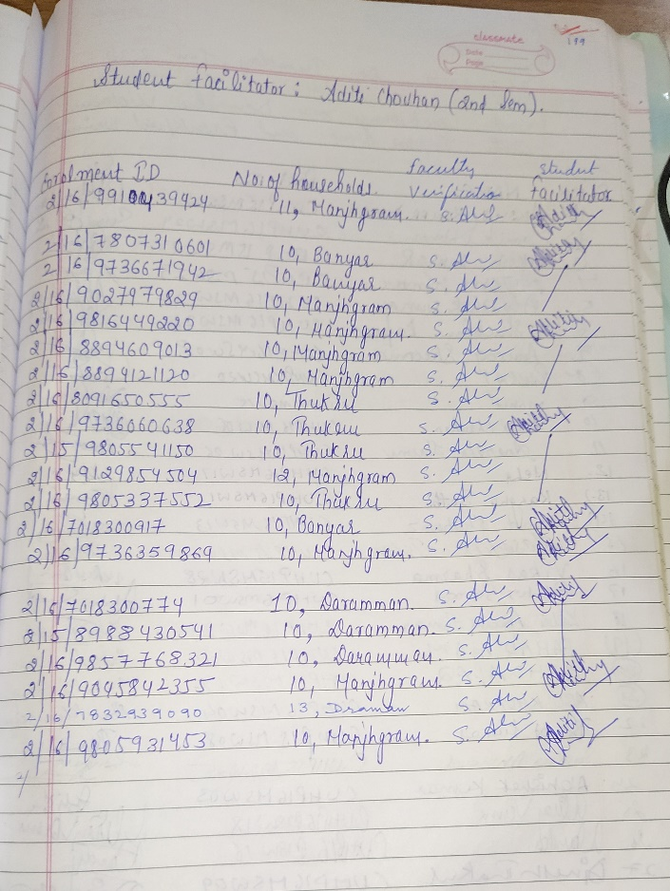
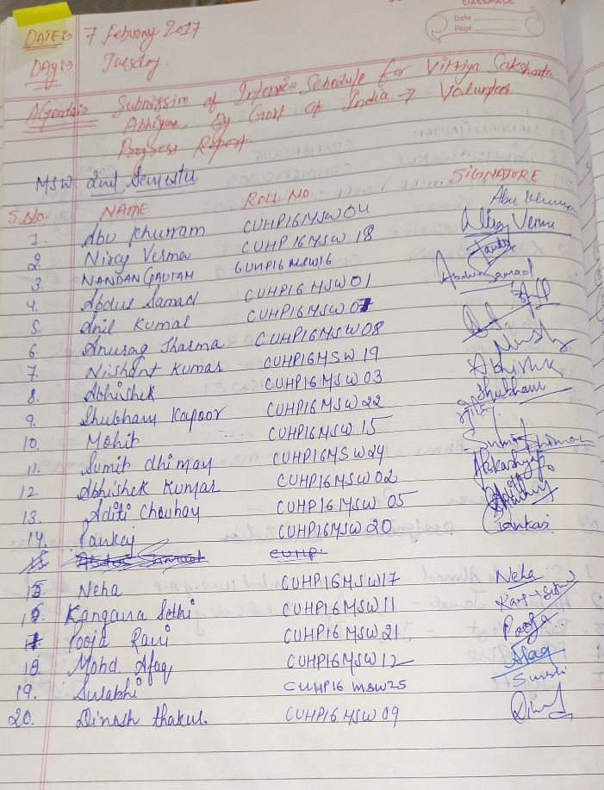

One Billion Rising India -2017
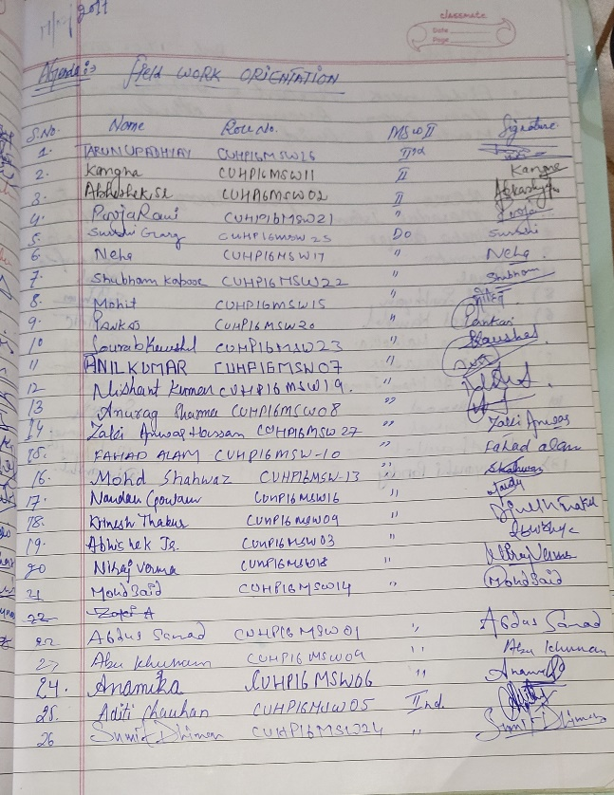
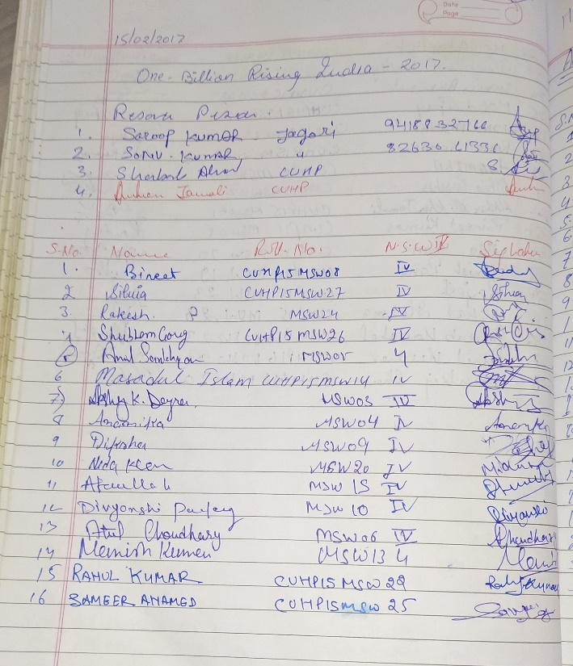
Every February, in each countries across the world join hands to show our local communities and the world what one billion looks like and shine a light on the rampant impunity and injustice that survivors most often face., Department of Social Work Participated in 1 Billion Raising Campaign. A day workshop organised by department of social work on 15th Feb 2017. The 2017 Rising was a global campaign demand to end ALL forms of exploitation of women and girls. In so many regions of the world, women are abused in multiple ways across layers of exploitation and oppression. One layer is the deeply entrenched patriarchal structures in society that continue to subordinate and oppress women, and conditions or forces women into submission and subjugation. This creates fertile ground for domination and control over them.

FGD Programme
FGD with students of Kelley Business School from INDIANA UNIVERSITY, USA collaboration with CORD.
